# Problem



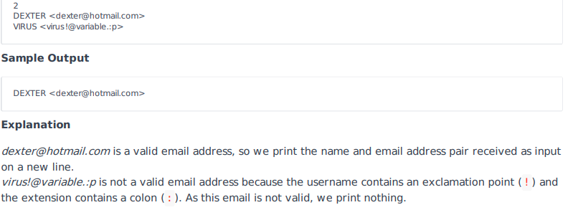

# Josh Solution

# Enter your code here. Read input from STDIN. Print output to STDOUT

import re

import email.utils

regex = r'\b[A-Za-z0-9._%+-]+@[A-Za-z0-9.-]+\.[A-Z|a-z]{2,}\b'

for _ in range(int(input())):

    i = input()

    i2 = i.split('<')

    i3 = i2[1]

    i4 = i3.rstrip('>')

    if re.match(regex,i4):

        print(i)

# Other Solutions

import re

n = int(input())

for _ in range(n):

x, y = input().split(' ')

m = re.match(r'<[A-Za-z](\w|-|\.|_)+@[A-Za-z]+\.[A-Za-z]{1,3}>', y)

if m:

print(x,y)